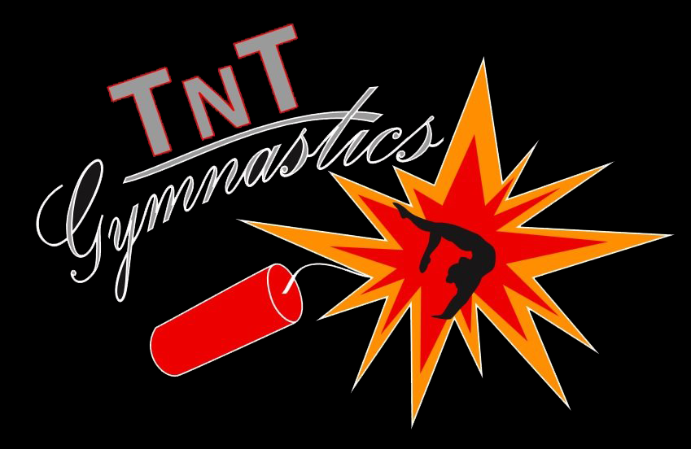

PRIVATE LESSONS

ONE HOUR LESSONS

**$75** - Single Lesson

**$300** - 5 Week Package

HALF HOUR LESSONS

**$45** - Single Lesson

**$175** - 5 Week Package

Paid directly to the instructor.